http://www.electronics-tutorials.ws

Combinational Logic Circuits Tutorial: 1 of 8

Combinational Logic Circuits
Unlike Sequential Logic Circuits whose outputs are dependant on both their present inputs and their previous output state giving them some form of Memory, the outputs of Combinational Logic Circuits are only determined by the logical function of their current input state, logic "0" or logic "1", at any given instant in time as they have no feedback, and any changes to the signals being applied to their inputs will immediately have an effect at the output. In other words, in a Combinational Logic Circuit, the output is dependant at all times on the combination of its inputs and if one of its inputs condition changes state so does the output as combinational circuits have "no memory", "timing" or "feedback loops".

Combinational Logic
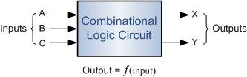
Combinational Logic Circuits are made up from basic logic NAND, NOR or NOT gates that are "combined" or connected together to produce more complicated switching circuits. These logic gates are the building blocks of combinational logic circuits. An example of a combinational circuit is a decoder, which converts the binary code data present at its input into a number of different output lines, one at a time producing an equivalent decimal code at its output.
Combinational logic circuits can be very simple or very complicated and any combinational circuit can be implemented with only NAND and NOR gates as these are classed as "universal" gates. The three main ways of specifying the function of a combinational logic circuit are:
- Truth Table Truth tables provide a concise list that shows the output values in tabular form for each possible combination of input variables.
- Boolean Algebra Forms an output expression for each input variable that represents a logic "1"
- Logic Diagram Shows the wiring and connections of each individual logic gate that implements the circuit.
and all three are shown below.
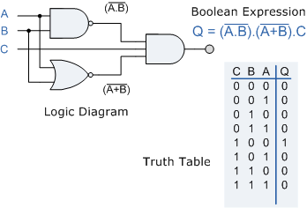
As combinational logic circuits are made up from individual logic gates only, they can also be considered as "decision making circuits" and combinational logic is about combining logic gates together to process two or more signals in order to produce at least one output signal according to the logical function of each logic gate. Common combinational circuits made up from individual logic gates that carry out a desired application include Multiplexers, De-multiplexers, Encoders, Decoders, Full and Half Adders etc.

Classification of Combinational Logic
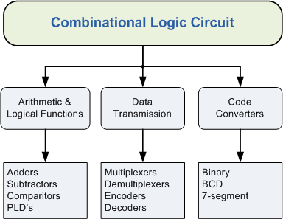
One of the most common uses of combinational logic is in Multiplexer and De-multiplexer type circuits. Here, multiple inputs or outputs are connected to a common signal line and logic gates are used to decode an address to select a single data input or output switch. A multiplexer consist of two separate components, a logic decoder and some solid state switches, but before we can discuss multiplexers, decoders and de-multiplexers in more detail we first need to understand how these devices use these "solid state switches" in their design.

Solid State Switches
Standard TTL logic devices made up from Transistors can only pass signal currents in one direction only making them "uni-directional" devices and poor imitations of conventional electro-mechanical switches or relays. However, some CMOS switching devices made up from FET's act as near perfect "bi-directional" switches making them ideal for use as solid state switches.
Solid state switches come in a variety of different types and ratings, and there are many different applications for using solid state switches. They can basically be sub-divided into 3 different main groups for switching applications and in this combinational logic section we will only look at the Analogue type of switch but the principal is the same for all types including digital.

Solid State Switch Applications
- Analogue Switches Data & Process Control, Video & Audio Switching, Instrumentation ...etc.
- Digital Switches High Speed Data Transmission, Switching & Routing, LAN's, USB ...etc.
- Power Switches Power Supplies and general "Standby Power" Switching Applications ...etc.

Analogue Bilateral Switches
Analogue or "Analog" switches are those types that are used to switch data or signal currents when they are in their "ON" state and block them when they are in their "OFF" state. The rapid switching between the "ON" and the "OFF" state is usually controlled by a digital signal applied to the control gate of the switch. An ideal analogue switch has zero resistance when "ON" (or closed), and infinite resistance when "OFF" (or open) and switches with R_{ON} values of less than 1Ω are commonly available.

Solid State Analogue Switch
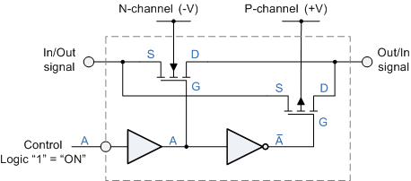
By connecting an N-channel MOSFET in parallel with a P-channel MOSFET allows signals to pass in either direction making it a Bi-directional switch and as to whether the N-channel or the P-channel device carries more signal current will depend upon the ratio between the input to the output voltage. The two MOSFETs are switched "ON" or "OFF" by two internal non-inverting and inverting amplifiers.

Contact Types
Just like mechanical switches, analogue switches come in a variety of forms or contact types, depending on the number of "poles" and "throws" they offer. Thus, terms such as "SPST" (single-pole single throw) and "SPDT" (single-pole double-throw) also apply to solid state analogue switches with "make-before-break" and "break-before-make" configurations available.

Analogue Switch Types
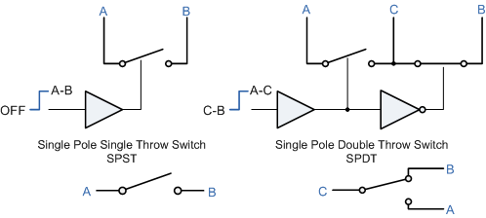
Individual analogue switches can be grouped together into standard IC packages to form devices with multiple switching configurations of SPST and SPDT as well as multi channel multiplexers. The most common and simplest analogue switch IC is the 74HC4066 which has 4 independent bi-directional "ON/OFF" Switches within a single package but the most widely used variants of the CMOS analogue switch are those described as "Multi-way Bilateral Switches" otherwise known as the "Multiplexer" and "De-multiplexer" IC´s and these are discussed in the next tutorial.

Combinational Logic Summary
Then to summarise, Combinational Logic Circuits consist of inputs, two or more basic logic gates and outputs. The logic gates are combined in such a way that the output state depends entirely on the input states. Combinational logic circuits have "no memory", "timing" or "feedback loops", there operation is instantaneous. A combinational logic circuit performs an operation assigned logically by a Boolean expression or truth table.
Examples of common combinational logic circuits include: half adders, full adders, multiplexers, demultiplexers, encoders and decoders all of which we will look at in the next few tutorials.

The Multiplexer Tutorial: 2 of 8

The Multiplexer
A data selector, more commonly called a Multiplexer, shortened to "Mux" or "MPX", are combinational logic switching devices that operate like a very fast acting multiple position rotary switch. They connect or control, multiple input lines called "channels" consisting of either 2, 4, 8 or 16 individual inputs, one at a time to an output. Then the job of a multiplexer is to allow multiple signals to share a single common output. For example, a single 8-channel multiplexer would connect one of its eight inputs to the single data output. Multiplexers are used as one method of reducing the number of logic gates required in a circuit or when a single data line is required to carry two or more different digital signals.
Digital Multiplexers are constructed from individual analogue switches encased in a single IC package as opposed to the "mechanical" type selectors such as normal conventional switches and relays. Generally, multiplexers have an even number of data inputs, usually an even power of two, n² , a number of "control" inputs that correspond with the number of data inputs and according to the binary condition of these control inputs, the appropriate data input is connected directly to the output. An example of a Multiplexer configuration is shown below.

4-to-1 Channel Multiplexer
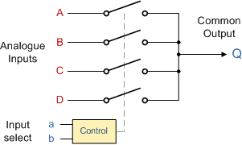

Addressing |  | Input  Selected
b | a
0 | 0 | A
0 | 1 | B
1 | 0 | C
1 | 1 | D
The Boolean expression for this 4-to-1 Multiplexer above with inputs A to D and data select lines a, b is given as:
Q = abA + abB + abC + abD
In this example at any one instant in time only ONE of the four analogue switches is closed, connecting only one of the input lines A to D to the single output at Q. As to which switch is closed depends upon the addressing input code on lines "a" and "b", so for this example to select input B to the output at Q, the binary input address would need to be "a" = logic "1" and "b" = logic "0". Adding more control address lines will allow the multiplexer to control more inputs but each control line configuration will connect only ONE input to the output.
Then the implementation of this Boolean expression above using individual logic gates would require the use of seven individual gates consisting of AND, OR and NOT gates as shown.

4 Channel Multiplexer using Logic Gates
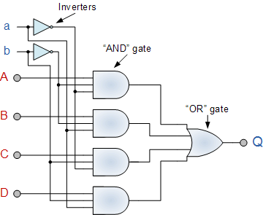
The symbol used in logic diagrams to identify a multiplexer is as follows.

Multiplexer Symbol
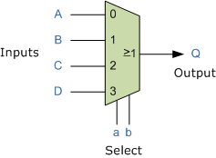
Multiplexers are not limited to just switching a number of different input lines or channels to one common single output. There are also types that can switch their inputs to multiple outputs and have arrangements or 4 to 2, 8 to 3 or even 16 to 4 etc configurations and an example of a simple Dual channel 4 input multiplexer (4 to 2) is given below:

4-to-2 Channel Multiplexer
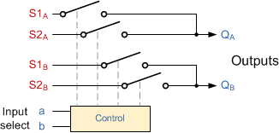
Here in this example the 4 input channels are switched to 2 individual output lines but larger arrangements are also possible. This simple 4 to 2 configuration could be used for example, to switch audio signals for stereo pre-amplifiers or mixers.

Adjustable Amplifier Gain
As well as sending parallel data in a serial format down a single transmission line or connection, another possible use of multi-channel multiplexers is in digital audio applications as mixers or where the gain of an analogue amplifier can be controlled digitally, for example.

Digitally Adjustable Amplifier Gain
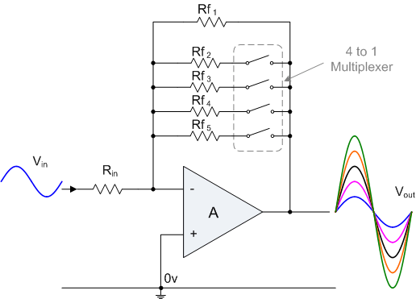
Here, the voltage gain of the inverting amplifier is dependent upon the ratio between the input resistor, Rin and its feedback resistor, Rf as determined in theOp-amp tutorials. A single 4-channel (Quad) SPST switch configured as a 4-to-1 channel multiplexer is connected in series with the resistors to select any feedback resistor to vary the value of Rf. The combination of these resistors will determine the overall gain of the amplifier, (Av). Then the gain of the amplifier can be adjusted digitally by simply selecting the appropriate resistor combination.
Digital multiplexers are sometimes also referred to as "Data Selectors" as they select the data to be sent to the output line and are commonly used in communications or high speed network switching circuits such as LAN´s and Ethernet applications. Some multiplexer IC´s have a single inverting buffer (NOT Gate) connected to the output to give a positive logic output (logic "1", HIGH) on one terminal and a complimentary negative logic output (logic "0", LOW) on another different terminal.
It is possible to make simple multiplexer circuits from standard AND and OR gates as we have seen above, but commonly multiplexers/data selectors are available as standard i.c. packages such as the common TTL 74LS151 8-input to 1 line multiplexer or the TTL 74LS153 Dual 4-input to 1 line multiplexer. Multiplexer circuits with much higher number of inputs can be obtained by cascading together two or more smaller devices.
The Multiplexer is a very useful combinational device that has its uses in many different applications such as signal routing, data communications and data bus control. When used with a demultiplexer, parallel data can be transmitted in serial form via a single data link such as a fibre-optic cable or telephone line. They can also be used to switch either analogue, digital or video signals, with the switching current in analogue power circuits limited to below 10mA to 20mA per channel in order to reduce heat dissipation.
In the next tutorial about combinational logic devices, we will look at the reverse of the Multiplexer called the Demultiplexer which takes a single input line and connects it to multiple output lines.

The Demultiplexer Tutorial: 3 of 8

The Demultiplexer
The data distributor, known more commonly as a Demultiplexer or "Demux", is the exact opposite of the Multiplexer we saw in the previous tutorial. The demultiplexer takes one single input data line and then switches it to any one of a number of individual output lines one at a time. The demultiplexer converts a serial data signal at the input to a parallel data at its output lines as shown below.

1-to-4 Channel De-multiplexer
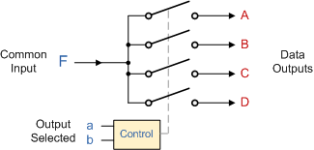
Addressing |  | Input  Selected
b | a
0 | 0 | A
0 | 1 | B
1 | 0 | C
1 | 1 | D

The Boolean expression for this 1-to-4 Demultiplexer above with outputs A to D and data select lines a, b is given as:
F = abA + abB + abC + abD
The function of the Demultiplexer is to switch one common data input line to any one of the 4 output data lines A to D in our example above. As with the multiplexer the individual solid state switches are selected by the binary input address code on the output select pins "a" and "b" and by adding more address line inputs it is possible to switch more outputs giving a 1-to-2^{n} data line outputs. Some standard demultiplexer IC´s also have an "enable output" input pin which disables or prevents the input from being passed to the selected output. Also some have latches built into their outputs to maintain the output logic level after the address inputs have been changed. However, in standard decoder type circuits the address input will determine which single data output will have the same value as the data input with all other data outputs having the value of logic "0".
The implementation of the Boolean expression above using individual logic gates would require the use of six individual gates consisting of AND and NOT gates as shown.

4 Channel Demultiplexer using Logic Gates
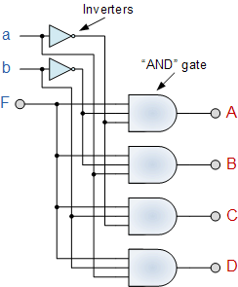
The symbol used in logic diagrams to identify a demultiplexer is as follows.

Demultiplexer Symbol
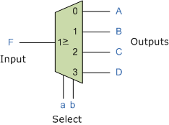
Standard Demultiplexer IC packages available are the TTL 74LS138 1 to 8-output demultiplexer, the TTL 74LS139 Dual 1-to-4 output demultiplexer or the CMOS CD4514 1-to-16 output demultiplexer. Another type of demultiplexer is the 24-pin, 74LS154 which is a 4-bit to 16-line demultiplexer/decoder. Here the individual output positions are selected using a 4-bit binary coded input. Like multiplexers, demultiplexers can also be cascaded together to form higher order demultiplexers.
Unlike multiplexers which convert data from a single data line to multiple lines and demultiplexers which convert multiple lines to a single data line, there are devices available which convert data to and from multiple lines and in the next tutorial about combinational logic devices, we will look at Encoders which convert multiple input lines into multiple output lines, converting the data from one form to another.

Priority Encoder Tutorial: 4 of 8

The Digital Encoder
Unlike a multiplexer that selects one individual data input line and then sends that data to a single output line or switch, a Digital Encoder more commonly called a Binary Encoder takes ALL its data inputs one at a time and then converts them into a single encoded output. So we can say that a binary encoder, is a multi-input combinational logic circuit that converts the logic level "1" data at its inputs into an equivalent binary code at its output. Generally, digital encoders produce outputs of 2-bit, 3-bit or 4-bit codes depending upon the number of data input lines. An "n-bit" binary encoder has 2^{n} input lines and n-bit output lines with common types that include 4-to-2, 8-to-3 and 16-to-4 line configurations. The output lines of a digital encoder generate the binary equivalent of the input line whose value is equal to "1" and are available to encode either a decimal or hexadecimal input pattern to typically a binary or B.C.D. output code.

4-to-2 Bit Binary Encoder
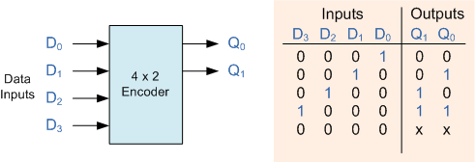
One of the main disadvantages of standard digital encoders is that they can generate the wrong output code when there is more than one input present at logic level "1". For example, if we make inputs D₁ and D₂ HIGH at logic "1" at the same time, the resulting output is neither at "01" or at "10" but will be at "11" which is an output binary number that is different to the actual input present. Also, an output code of all logic "0"s can be generated when all of its inputs are at "0" OR when input D₀ is equal to one.
One simple way to overcome this problem is to "Prioritise" the level of each input pin and if there was more than one input at logic level "1" the actual output code would only correspond to the input with the highest designated priority. Then this type of digital encoder is known commonly as a Priority Encoder or P-encoder for short.

Priority Encoder
The Priority Encoder solves the problems mentioned above by allocating a priority level to each input. The priority encoders output corresponds to the currently active input which has the highest priority. So when an input with a higher priority is present, all other inputs with a lower priority will be ignored. The priority encoder comes in many different forms with an example of an 8-input priority encoder along with its truth table shown below.

8-to-3 Bit Priority Encoder
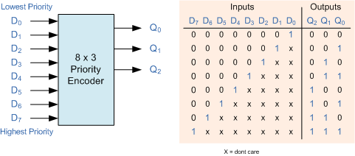
Priority encoders are available in standard IC form and the TTL 74LS148 is an 8-to-3 bit priority encoder which has eight active LOW (logic "0") inputs and provides a 3-bit code of the highest ranked input at its output. Priority encoders output the highest order input first for example, if input lines "D2", "D3" and "D5" are applied simultaneously the output code would be for input "D5" ("101") as this has the highest order out of the 3 inputs. Once input "D5" had been removed the next highest output code would be for input "D3" ("011"), and so on.
The truth table for a 8-to-3 bit priority encoder is given as:
Digital Inputs |  |  |  |  |  |  |  | Binary Output
D₇ | D₆ | D₅ | D₄ | D₃ | D₂ | D₁ | D₀ | Q₂ | Q₁ | Q₀
0 | 0 | 0 | 0 | 0 | 0 | 0 | 1 | 0 | 0 | 0
0 | 0 | 0 | 0 | 0 | 0 | 1 | X | 0 | 0 | 1
0 | 0 | 0 | 0 | 0 | 1 | X | X | 0 | 1 | 0
0 | 0 | 0 | 0 | 1 | X | X | X | 0 | 1 | 1
0 | 0 | 0 | 1 | X | X | X | X | 1 | 0 | 0
0 | 0 | 1 | X | X | X | X | X | 1 | 0 | 1
0 | 1 | X | X | X | X | X | X | 1 | 1 | 0
1 | X | X | X | X | X | X | X | 1 | 1 | 1
From this truth table, the Boolean expression for the encoder above with inputs D₀ to D₇ and outputs Q₀, Q₁, Q₂ is given as:
Output Q₀
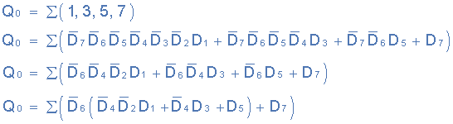
Output Q₁
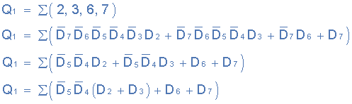
Output Q₂
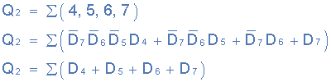
Then the final Boolean expression for the priority encoder including the zero inputs is defined as:
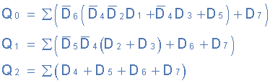
In practice these zero inputs would be ignored allowing the implementation of the final Boolean expression for the outputs of the 8-to-3 priority encoder above to be constructed using individual OR gates as follows.

Digital Encoder using Logic Gates
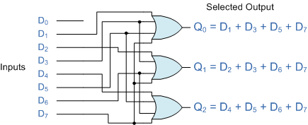

Encoder Applications

Keyboard Encoder
Priority encoders can be used to reduce the number of wires needed in a particular circuits or application that have multiple inputs. For example, assume that a microcomputer needs to read the 104 keys of a standard QWERTY keyboard where only one key would be pressed either "HIGH" or "LOW" at any one time. One way would be to connect all 104 wires from the keys directly to the computer but this would be impractical for a small home PC, but another better way would be to use a priority encoder. The 104 individual buttons or keys could be encoded into a standard ASCII code of only 7-bits (0 to 127 decimal) to represent each key or character of the keyboard and then inputted as a much smaller 7-bit B.C.D code directly to the computer. Keypad encoders such as the 74C923 20-key encoder are available to do just that.

Positional Encoders
Another more common application is in magnetic positional control as used on ships or robots etc. Here the angular or rotary position of a compass is converted into a digital code by an encoder and inputted to the systems computer to provide navigational data and an example of a simple 8 position to 3-bit output compass encoder is shown below. Magnets and reed switches could be used to indicate the compasses angular position.
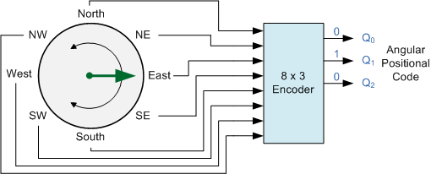
Compass Direction | Binary Output
 | Q₀ | Q₁ | Q₂
North | 0 | 0 | 0
North-East | 0 | 0 | 1
East | 0 | 1 | 0
South-East | 0 | 1 | 1
South | 1 | 0 | 0
South-West | 1 | 0 | 1
West | 1 | 1 | 0
North-West | 1 | 1 | 1

Interrupt Requests
Other applications especially for Priority Encoders may include detecting interrupts in microprocessor applications. Here the microprocessor uses interrupts to allow peripheral devices such as the disk drive, scanner, mouse, or printer etc, to communicate with it, but the microprocessor can only "talk" to one peripheral device at a time. The processor uses "Interrupt Requests" or "IRQ" signals to assign priority to the devices to ensure that the most important peripheral device is serviced first. The order of importance of the devices will depend upon their connection to the priority encoder.
IRQ Number | Typical Use | Description
IRQ 0 | System timer | Internal System Timer.
IRQ 1 | Keyboard | Keyboard Controller.
IRQ 3 | COM2 & COM4 | Second and Fourth Serial Port.
IRQ 4 | COM1 & COM3 | First and Third Serial Port.
IRQ 5 | Sound | Sound Card.
IRQ 6 | Floppy disk | Floppy Disk Controller.
IRQ 7 | Parallel port | Parallel Printer.
IRQ 12 | Mouse | PS/2 Mouse.
IRQ 14 | Primary IDE | Primary Hard Disk Controller.
IRQ 15 | Secondary IDE | Secondary Hard Disk Controller.
Because implementing such a system using priority encoders such as the standard 74LS148 priority encoder IC involves additional logic circuits, purpose built integrated circuits such as the 8259 Programmable Priority Interrupt Controller is available.

Digital Encoder Summary
Then to summarise, the Digital Encoder is a combinational circuit that generates a specific code at its outputs such as binary or BCD in response to one or more active inputs. There are two main types of digital encoder. The Binary Encoder and the Priority Encoder.
The Binary Encoder converts one of 2^{n} inputs into an n-bit output. Then a binary encoder has fewer output bits than the input code. Binary encoders are useful for compressing data and can be constructed from simple AND or OR gates. One of the main disadvantages of a standard binary encoder is that it would produce an error at its outputs if more than one input were active at the same time. To overcome this problem priority encoders were developed.
The Priority Encoder is another type of combinational circuit similar to a binary encoder, except that it generates an output code based on the highest prioritised input. Priority encoders are used extensively in digital and computer systems as microprocessor interrupt controllers where they detect the highest priority input.
In the next tutorial about combinational logic devices, we will look at complementary function of the encoder called a Decoder which convert an n-bit input code to one of its 2^{n} output lines.

The Binary Decoder Tutorial: 5 of 8

Binary Decoder
A Decoder is the exact opposite to that of an "Encoder" we looked at in the last tutorial. It is basically, a combinational type logic circuit that converts the binary code data at its input into one of a number of different output lines, one at a time producing an equivalent decimal code at its output. Binary Decoders have inputs of 2-bit, 3-bit or 4-bit codes depending upon the number of data input lines, and a n-bit decoder has 2^{n} output lines. Therefore, if it receives n inputs (usually grouped as a binary or Boolean number) it activates one and only one of its 2^{n} outputs based on that input with all other outputs deactivated. A decoders output code normally has more bits than its input code and practical binary decoder circuits include, 2-to-4, 3-to-8 and 4-to-16 line configurations.
A binary decoder converts coded inputs into coded outputs, where the input and output codes are different and decoders are available to "decode" either a Binary or BCD (8421 code) input pattern to typically a Decimal output code. Commonly available BCD-to-Decimal decoders include the TTL 7442 or the CMOS 4028. An example of a 2-to-4 line decoder along with its truth table is given below. It consists of an array of four NAND gates, one of which is selected for each combination of the input signals A and B.

A 2-to-4 Binary Decoders.
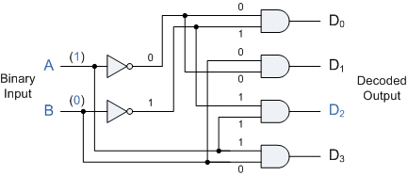

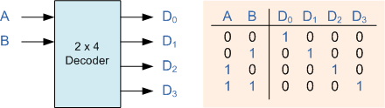
In this simple example of a 2-to-4 line binary decoder, the binary inputs A and B determine which output line from D0 to D3is "HIGH" at logic level "1" while the remaining outputs are held "LOW" at logic "0" so only one output can be active (HIGH) at any one time. Therefore, whichever output line is "HIGH" identifies the binary code present at the input, in other words it "de-codes" the binary input and these types of binary decoders are commonly used as Address Decoders in microprocessor memory applications.
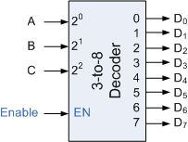
74LS138 Binary Decoder
Some binary decoders have an additional input labelled "Enable" that controls the outputs from the device. This allows the decoders outputs to be turned "ON" or "OFF" and we can see that the logic diagram of the basic decoder is identical to that of the basic demultiplexer. Therefore, we say that a demultiplexer is a decoder with an additional data line that is used to enable the decoder. An alternative way of looking at the decoder circuit is to regard inputs A, B and C as address signals. Each combination of A, B or C defines a unique address which can access a location having that address.
Sometimes it is required to have a Binary Decoder with a number of outputs greater than is available, or if we only have small devices available, we can combine multiple decoders together to form larger decoder networks as shown. Here a much larger 4-to-16 line binary decoder has been implemented using two smaller 3-to-8 decoders.

A 4-to-16 Binary Decoder Configuration.
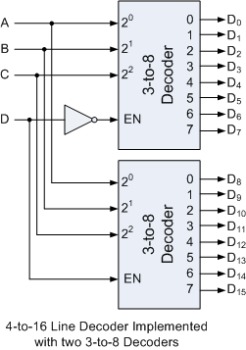
Inputs A, B, C are used to select which output on either decoder will be at logic "1" (HIGH) and input D is used with the enable input to select which encoder either the first or second will output the "1".

Memory Address Decoder.
Binary Decoders are most often used in more complex digital systems to access a particular memory location based on an "address" produced by a computing device. In modern microprocessor systems the amount of memory required can be quite high and is generally more than one single memory chip alone. One method of overcoming this problem is to connect lots of individual memory chips together and to read the data on a common "Data Bus". In order to prevent the data being "read" from each memory chip at the same time, each memory chip is selected individually one at time and this process is known as Address Decoding.
In this application, the address represents the coded data input, and the outputs are the particular memory element select signals. Each memory chip has an input called Chip Select or CS which is used by the MPU to select the appropriate memory chip and a logic "1" on this input selects the device and a logic "0" on the input de-selects it. By selecting or de-selecting each chip, allows us to select the correct memory device for a particular address and when we specify a particular memory address, the corresponding memory location exists ONLY in one of the chips.
For example, Lets assume we have a very simple microprocessor system with only 1Kb of RAM memory and 10 address lines. The memory consists of 128x8-bit (128x8 = 1024 bytes) devices and for 1Kb we will need 8 individual memory devices but in order to select the correct memory chip we will also require a 3-to-8 line binary decoder as shown below.

Memory Address Decoding.
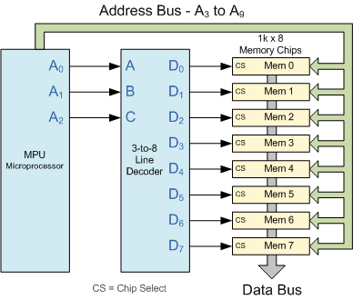
The binary decoder requires 3 address lines, (A₀ to A₂) to select each one of the 8 chips (the lower part of the address), while the remaining 7 address lines (A₃ to A₉) select the correct memory location on that chip (the upper part of the address). Having selected a memory location using the address bus, the information at the particular internal memory location is sent to the "Data Bus" for use by the microprocessor. This is of course a simple example but the principals remain the same for all types of memory chips or modules.
Binary Decoders are very useful devices for converting one digital format to another, such as binary or BCD type data into decimal or octal etc and commonly available decoder IC's are the TTL 74LS138 3-to-8 line binary decoder or the 74ALS154 4-to-16 line decoder. They are also very useful for interfacing to 7-segment displays such as the TTL 74LS47 which we will look at in the next tutorial.

Display Decoder Tutorial: 6 of 8

BCD to 7-Segment Display Decoder
As we saw in the previous tutorial, a Decoder IC, is a device which converts one digital format into another and the most commonly used device for doing this is the Binary Coded Decimal (BCD) to 7-Segment Display Decoder. 7-segment LED (Light Emitting Diode) or LCD (Liquid Crystal) displays, provide a very convenient way of displaying information or digital data in the form of numbers, letters or even alpha-numerical characters and they consist of 7 individual LED's (the segments), within one single display package.
In order to produce the required numbers or HEX characters from 0 to 9 and A to F respectively, on the display the correct combination of LED segments need to be illuminated and BCD to 7-segment Display Decoders such as the 74LS47 do just that. A standard 7-segment LED display generally has 8 input connections, one for each LED segment and one that acts as a common terminal or connection for all the internal segments. Some single displays have an additional input pin for the decimal point in their lower right or left hand corner.
There are two important types of 7-segment LED digital display.
- The Common Cathode Display (CCD) - In the common cathode display, all the cathode connections of the LED's are joined together to logic "0" and the individual segments are illuminated by application of a "HIGH", logic "1" signal to the individual Anode terminals.
- The Common Anode Display (CAD) - In the common anode display, all the anode connections of the LED's are joined together to logic "1" and the individual segments are illuminated by connecting the individual Cathode terminals to a "LOW", logic "0" signal.

7-Segment Display Format
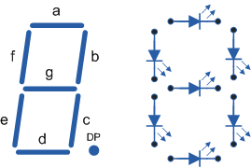

Truth Table for a 7-segment display
Individual Segments Display  a b c d e f g  × × × × × × 0  × × 1  × × × × × 2  × × × × × 3  × × × × 4  × × × × × 5  × × × × × × 6  × × × 7 | Individual Segments Display  a b c d e f g  × × × × × × × 8  × × × × × 9  × × × × × × A  × × × × × b  × × × × C  × × × × × d  × × × × × E  × × × × F

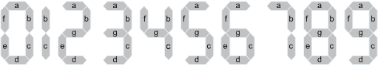
7-Segment Display Elements for all Numbers.
It can be seen that to display any single digit number from 0 to 9 or letter from A to F, we would need 7 separate segment connections plus one additional connection for the LED's "common" connection. Also as the segments are basically a standard light emitting diode, the driving circuit would need to produce up to 20mA of current to illuminate each individual segment and to display the number 8, all 7 segments would need to be lit resulting a total current of nearly 140mA, (8 x 20mA). Obviously, the use of so many connections and power consumption is impractical for some electronic or microprocessor based circuits and so in order to reduce the number of signal lines required to drive just one single display, display decoders such as the BCD to 7-Segment Display Decoder and Driver IC's are used instead.

Binary Coded Decimal
Binary Coded Decimal (BCD or "8421" BCD) numbers are made up using just 4 data bits (a nibble or half a byte) similar to the Hexadecimal numbers we saw in the binary tutorial, but unlike hexadecimal numbers that range in full from 0 through to F, BCD numbers only range from 0 to 9, with the binary number patterns of 1010 through to 1111 (A to F) being invalid inputs for this type of display and so are not used as shown below.
Decimal Binary Pattern BCD  8 4 2 1  0 0 0 0 0 0  1 0 0 0 1 1  2 0 0 1 0 2  3 0 0 1 1 3  4 0 1 0 0 4  5 0 1 0 1 5  6 0 1 1 0 6  7 0 1 1 1 7 |  | Decimal Binary Pattern BCD  8 4 2 1  8 1 0 0 0 8  9 1 0 0 1 9  10 1 0 1 0 Invalid  11 1 0 1 1 Invalid  12 1 1 0 0 Invalid  13 1 1 0 1 Invalid  14 1 1 1 0 Invalid  15 1 1 1 1 Invalid

BCD to 7-Segment Display Decoders
A binary coded decimal (BCD) to 7-segment display decoder such as the TTL 74LS47 or 74LS48, have 4 BCD inputs and 7 output lines, one for each LED segment. This allows a smaller 4-bit binary number (half a byte) to be used to display all the denary numbers from 0 to 9 and by adding two displays together, a full range of numbers from 00 to 99 can be displayed with just a single byte of 8 data bits.

BCD to 7-Segment Decoder
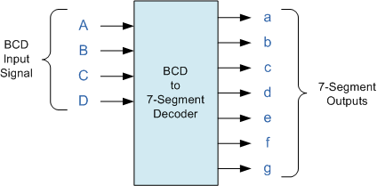
The use of packed BCD allows two BCD digits to be stored within a single byte (8-bits) of data, allowing a single data byte to hold a BCD number in the range of 00 to 99.
An example of the 4-bit BCD input (0100) representing the number 4 is given below.

Example No1
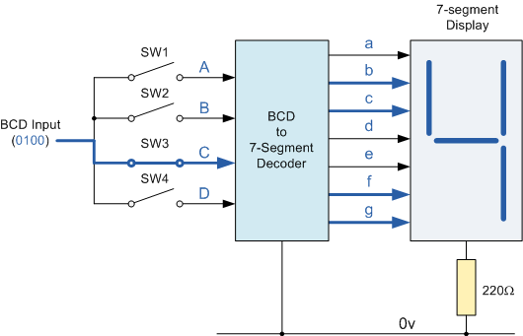
In practice current limiting resistors of about 150Ω to 220Ω would be connected in series between the decoder/driver chip and each LED display segment to limit the maximum current flow. Different display decoders or drivers are available for the different types of display available, e.g. 74LS48 for common-cathode LED types, 74LS47 for common-anode LED types, or the CMOS CD4543 for liquid crystal display (LCD) types.
Liquid crystal displays (LCD´s) have one major advantage over similar LED types in that they consume much less power and nowadays, both LCD and LED displays are combined together to form larger Dot-Matrix Alphanumeric type displays which can show letters and characters as well as numbers in standard Red or Tri-colour outputs.

The Binary Adder Tutorial: 7 of 8

The Binary Adder
Another common and very useful combinational logic circuit which can be constructed using just a few basic logic gates and adds together binary numbers is the Binary Adder circuit. The Binary Adder is made up from standard AND and Ex-OR gates and allow us to "add" together single bit binary numbers, a and b to produce two outputs, the SUM of the addition and a CARRY called the Carry-out, ( Cout ) bit. One of the main uses for the Binary Adder is in arithmetic and counting circuits.
Consider the addition of two denary (base 10) numbers below.
123 | A | (Augend)
+ 789 | B | (Addend)
912 | SUM
Each column is added together starting from the right hand side and each digit has a weighted value depending upon its position in the columns. As each column is added together a carry is generated if the result is greater or equal to ten, the base number. This carry is then added to the result of the addition of the next column to the left and so on, simple school math's addition. The adding of binary numbers is basically the same as that of adding decimal numbers but this time a carry is only generated when the result in any column is greater or equal to "2", the base number of binary.

Binary Addition
Binary Addition follows the same basic rules as for the denary addition above except in binary there are only two digits and the largest digit is "1", so any "SUM" greater than 1 will result in a "CARRY". This carry 1 is passed over to the next column for addition and so on. Consider the single bit addition below.
0 | 0 | 1 | 1
+ 0 | + 1 | + 0 | + 1
0 | 1 | 1 | 10
The single bits are added together and "0 + 0", "0 + 1", or "1 + 0" results in a sum of "0" or "1" until you get to "1 + 1" then the sum is equal to "2". For a simple 1-bit addition problem like this, the resulting carry bit could be ignored which would result in an output truth table resembling that of an Ex-OR Gate as seen in the Logic Gates section and whose result is the sum of the two bits but without the carry. An Ex-OR gate only produces an output "1" when either input is at logic "1", but not both. However, all microprocessors and electronic calculators require the carry bit to correctly calculate the equations so we need to rewrite them to include 2 bits of output data as shown below.
00 | 00 | 01 | 01
+ 00 | + 01 | + 00 | + 01
00 | 01 | 01 | 10
From the above equations we know that an Ex-OR gate will only produce an output "1" when "EITHER" input is at logic "1", so we need an additional output to produce a carry output, "1" when "BOTH" inputs "A" and "B" are at logic "1" and a standard AND Gate fits the bill nicely. By combining the Ex-OR gate with the AND gate results in a simple digital binary adder circuit known commonly as the "Half Adder" circuit.

The Half Adder Circuit

1-bit Adder with Carry-Out
Symbol | Truth Table
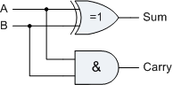 | A | B | SUM | CARRY
 | 0 | 0 | 0 | 0
 | 0 | 1 | 1 | 0
 | 1 | 0 | 1 | 0
 | 1 | 1 | 0 | 1
Boolean Expression: Sum = A ⊕ B Carry = A . B
From the truth table we can see that the SUM (S) output is the result of the Ex-OR gate and the Carry-out (Cout) is the result of theAND gate. One major disadvantage of the Half Adder circuit when used as a binary adder, is that there is no provision for a "Carry-in" from the previous circuit when adding together multiple data bits. For example, suppose we want to add together two 8-bit bytes of data, any resulting carry bit would need to be able to "ripple" or move across the bit patterns starting from the least significant bit (LSB). The most complicated operation the half adder can do is "1 + 1" but as the half adder has no carry input the resultant added value would be incorrect. One simple way to overcome this problem is to use a Full Adder type binary adder circuit.

The Full Adder Circuit
The main difference between the Full Adder and the previous seen Half Adder is that a full adder has three inputs, the same two single bit binary inputs A and B as before plus an additional Carry-In (C-in) input as shown below.

Full Adder with Carry-In
Symbol | Truth Table
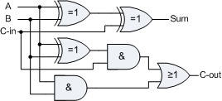 | A | B | C-in | Sum | C-out
 | 0 | 0 | 0 | 0 | 0
 | 0 | 1 | 0 | 1 | 0
 | 1 | 0 | 0 | 1 | 0
 | 1 | 1 | 0 | 0 | 1
 | 0 | 0 | 1 | 1 | 0
 | 0 | 1 | 1 | 0 | 1
 | 1 | 0 | 1 | 0 | 1
 | 1 | 1 | 1 | 1 | 1
Boolean Expression: Sum = A ⊕ B ⊕ C-in
The 1-bit Full Adder circuit above is basically two half adders connected together and consists of three Ex-OR gates, two AND gates and an OR gate, six logic gates in total. The truth table for the full adder includes an additional column to take into account the Carry-in input as well as the summed output and carry-output. 4-bit full adder circuits are available as standard IC packages in the form of the TTL 74LS83 or the 74LS283 which can add together two 4-bit binary numbers and generate a SUM and a CARRY output. But what if we wanted to add together two n-bit numbers, then n 1-bit full adders need to be connected together to produce what is known as the Ripple Carry Adder.

The 4-bit Binary Adder
The Ripple Carry Binary Adder is simply n, full adders cascaded together with each full adder represents a single weighted column in the long addition with the carry signals producing a "ripple" effect through the binary adder from right to left. For example, suppose we want to "add" together two 4-bit numbers, the two outputs of the first full adder will provide the first place digit sum of the addition plus a carry-out bit that acts as the carry-in digit of the next binary adder. The second binary adder in the chain also produces a summed output (the 2nd bit) plus another carry-out bit and we can keep adding more full adders to the combination to add larger numbers, linking the carry bit output from the first full binary adder to the next full adder, and so forth. An example of a 4-bit adder is given below.

A 4-bit Binary Adder
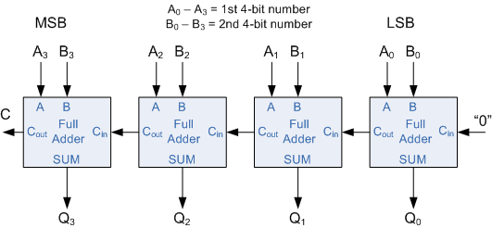
One main disadvantage of "cascading" together 1-bit binary adders to add large binary numbers is that if inputs A and B change, the sum at its output will not be valid until any carry-input has "rippled" through every full adder in the chain. Consequently, there will be a finite delay before the output of a adder responds to a change in its inputs resulting in the accumulated delay especially in large multi-bit binary adders becoming prohibitively large. This delay is called Propagation delay. Also "overflow" occurs when an n-bit adder adds two numbers together whose sum is greater than or equal to 2^{n}
One solution is to generate the carry-input signals directly from the A and B inputs rather than using the ripple arrangement above. This then produces another type of binary adder circuit called a Carry Look Ahead Binary Adder were the speed of the parallel adder can be greatly improved using carry-look ahead logic.

The 4-bit Binary Subtractor
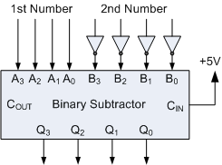
Now that we know how to "ADD" together two 4-bit binary numbers how would we subtract two 4-bit binary numbers, for example, A - B using the circuit above. The answer is to use 2’s-complement notation on all the bits in B must be complemented (inverted) and an extra one added using the carry-input. This can be achieved by inverting each B input bit using an inverter or NOT-gate.
Also, in the above circuit for the 4-bit binary adder, the first carry-in input is held LOW at logic "0", for the circuit to perform subtraction this input needs to be held HIGH at "1". With this in mind a ripple carry adder can with a small modification be used to perform half subtraction, full subtraction and/or comparison.
There are a number of 4-bit full-adder ICs available such as the 74LS283 and CD4008. which will add two 4-bit binary number and provide an additional input carry bit, as well as an output carry bit, so you can cascade them together to produce 8-bit, 12-bit, 16-bit, etc. adders.

Digital Comparator Tutorial: 8 of 8

The Digital Comparator
Another common and very useful combinational logic circuit is that of the Digital Comparatorcircuit. Digital or Binary Comparators are made up from standard AND, NOR and NOT gates that compare the digital signals present at their input terminals and produce an output depending upon the condition of those inputs. For example, along with being able to add and subtract binary numbers we need to be able to compare them and determine whether the value of input A is greater than, smaller than or equal to the value at input B etc. The digital comparator accomplishes this using several logic gates that operate on the principles of Boolean algebra. There are two main types of digital comparator available and these are.
- Identity Comparator - is a digital comparator that has only one output terminal for when A = B either "HIGH" A = B = 1 or "LOW" A = B = 0
- Magnitude Comparator - is a type of digital comparator that has three output terminals, one each for equality, A = B greater than, A > B and less than A < B
The purpose of a Digital Comparator is to compare a set of variables or unknown numbers, for example A (A1, A2, A3, .... An, etc) against that of a constant or unknown value such asB (B1, B2, B3, .... Bn, etc) and produce an output condition or flag depending upon the result of the comparison. For example, a magnitude comparator of two 1-bits, (A and B) inputs would produce the following three output conditions when compared to each other.
Which means: A is greater than B, A is equal to B, and A is less than B
This is useful if we want to compare two variables and want to produce an output when any of the above three conditions are achieved. For example, produce an output from a counter when a certain count number is reached. Consider the simple 1-bit comparator below.

1-bit Comparator
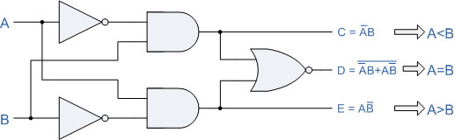
Then the operation of a 1-bit digital comparator is given in the following Truth Table.

Truth Table
Inputs |  | Outputs
B | A | A > B | A = B | A < B
0 | 0 | 0 | 1 | 0
0 | 1 | 1 | 0 | 0
1 | 0 | 0 | 0 | 1
1 | 1 | 0 | 1 | 0
You may notice two distinct features about the comparator from the above truth table. Firstly, the circuit does not distinguish between either two "0" or two "1"'s as an output A = B is produced when they are both equal, either A = B = "0" or A = B = "1". Secondly, the output condition for A = B resembles that of a commonly available logic gate, the Exclusive-NOR or Ex-NOR function (equivalence) on each of the n-bits giving: Q = A ⊕ B
Digital comparators actually use Exclusive-NOR gates within their design for comparing their respective pairs of bits. When we are comparing two binary or BCD values or variables against each other, we are comparing the "magnitude" of these values, a logic "0" against a logic "1" which is where the term Magnitude Comparator comes from.
As well as comparing individual bits, we can design larger bit comparators by cascading together n of these and produce a n-bit comparator just as we did for the n-bit adder in the previous tutorial. Multi-bit comparators can be constructed to compare whole binary or BCD words to produce an output if one word is larger, equal to or less than the other. A very good example of this is the 4-bit Magnitude Comparator. Here, two 4-bit words ("nibbles") are compared to each other to produce the relevant output with one word connected to inputs A and the other to be compared against connected to input B as shown below.

4-bit Magnitude Comparator
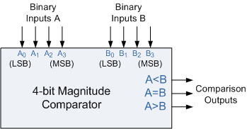
Some commercially available digital comparators such as the TTL 7485 or CMOS 4063 4-bit magnitude comparator have additional input terminals that allow more individual comparators to be "cascaded" together to compare words larger than 4-bits with magnitude comparators of "n"-bits being produced. These cascading inputs are connected directly to the corresponding outputs of the previous comparator as shown to compare 8, 16 or even 32-bit words.

8-bit Word Comparator
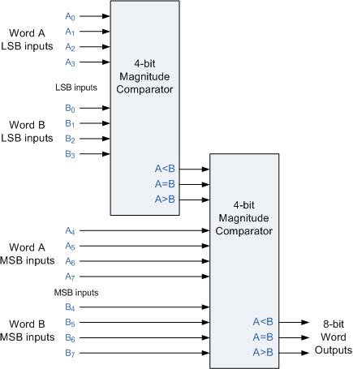
When comparing large binary or BCD numbers like the example above, to save time the comparator starts by comparing the highest-order bit (MSB) first. If equality exists, A = B then it compares the next lowest bit and so on until it reaches the lowest-order bit, (LSB). If equality still exists then the two numbers are defined as being equal. If inequality is found, either A > B or A < B the relationship between the two numbers is determined and the comparison between any additional lower order bits stops. Digital Comparator are used widely in Analogue-to-Digital converters, (ADC) and Arithmetic Logic Units, (ALU) to perform a variety of arithmetic operations.

